SDL Tutorial 2

Opening an SDL Window

Before starting this tutorial make sure you have completed Tutorial 1 – Setting up SDL.

In this tutorial we are going to go through the basics of opening a simple window in SDL. The code will be supplied at each step along with explanations.

1. Open your SDL project in Visual Studio.
2. As games will tend to accumulate a lot of constants we will need to set up a file to hold these.
   1. Create ‘Constants.h’ and input the following code:

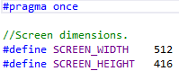

1. Back in the main source file include the constants file file.
2. We are going to be using the functionality provided by iostream.h, so include this in to your source file. Remember to setup the std namespace with:



1. Add the following just below the include declarations:



1. We will be splitting the code up in to separate functions. This will give us bite size chunks to work through. Add the following function prototypes to your file:



1. In the main function add the following:

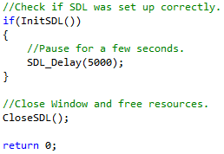

1. Now we will look at the initialise function for SDL: InitSDL().
   1. To be able to call any SDL functions we must first initialise SDL. If for some reason SDL does not set up correctly then we will inform the user and return false.

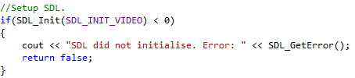

The SDL_INIT_VIDEO flag passed in to the SDL_Init function is to specify that we are using the video subsystems.

The other flags available are:

SDL_INIT_TIMER The Timer subsystem.

SDL_INIT_AUDIO The Audio subsystem.

SDL_INIT_CDROM The CDRom subsystem.

SDL_INIT_JOYSTICK The Joystick subsystem

SDL_INIT_EVERYTHING All of the above

SDL_INIT_NOPARACHUTE Prevents SDL from catching fatal signals

SDL_INIT_EVENTTHREAD Runs the event manager in a separate thread.

Multiple flags can be set by using the | operator.

For example: SDL_Init(SDL_INIT_VIDEO | SDL_INIT_AUDIO)

SDL_Init will return -1 to signify the initialisation failed and 0 on success. On failure we need to inform the user what went wrong. Using the SDL_GetError() function allows us to detail what the error was.

* 1. If setup goes well we need to create a window. This will use the dimensions we set in the Constants header file.

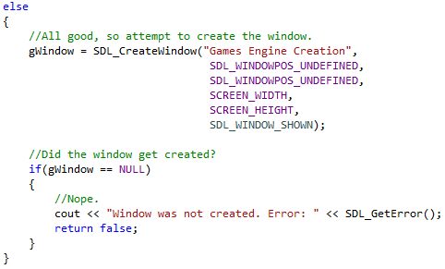

The SDL_CreateWindow() function will create us a window and return a pointer to a SDL_Window. The parameters are as follows:

* The first is a string that will be displayed in the bar at the top of the window.
* The next two are screen positions, X and Y. SDL_WINDOW_UNDEFINED allows us to not set a particular position.
* The fourth is an integer to define the width of the new window.
* The fifth is also an integer, but this one specifies the height of the new window.
* The final is a flag to state whether the window should be instantly shown.

The other available window flags are:

SDL_WINDOW_FULLSCREEN Fullscreen window

SDL_WINDOW_FULLSCREEN_DESKTOP Fullscreen window at current desktop resolution

SDL_WINDOW_OPENGL Window usable with OpenGL context

SDL_WINDOW_HIDDEN Window is not visible

SDL_WINDOW_BORDERLESS No window decoration

SDL_WINDOW_RESIZABLE Window can be resized

SDL_WINDOW_MINIMIZED Window is minimized

SDL_WINDOW_MAXIMISED Window is maximised

SDL_WINDOW_INPUT_GRABBED Window has grab input focus

SDL_WINDOW_INPUT_FOCUS Window has input focus

SDL_WINDOW_MOUSE_FOCUS Window has mouse focus

SDL_WINDOW_FORIEGN Window not created by SDL

SDL_WINDOW_ALLOW_HIGHDPI Window should be created with High-DPI format

(if supported)

Back to the code, we make a check to see if the window was created. It the pointer returned was NULL there was an error. We need to catch this error and output the error to the user.

* 1. If the code progresses without returning out of the InitSDL() function then all must have been set up correctly. So return true.



1. The remaining function to be discussed is the CloseSDL() function. This is where we need to free up the memory used and close the SDL subsytems that have been set up.
   1. First free the memory from the window.



* 1. Next call the SDL functions to quit the subsytems.



1. Now build and run the program.

Upon completion of this tutorial a plain window should open and remain on the screen for 5 seconds before automatically closing. In the next tutorial we will be looking at using SDL Events to allow us to close the window using the X in the window.